Successful GitHub Actions CI/CD Pipeline Execution
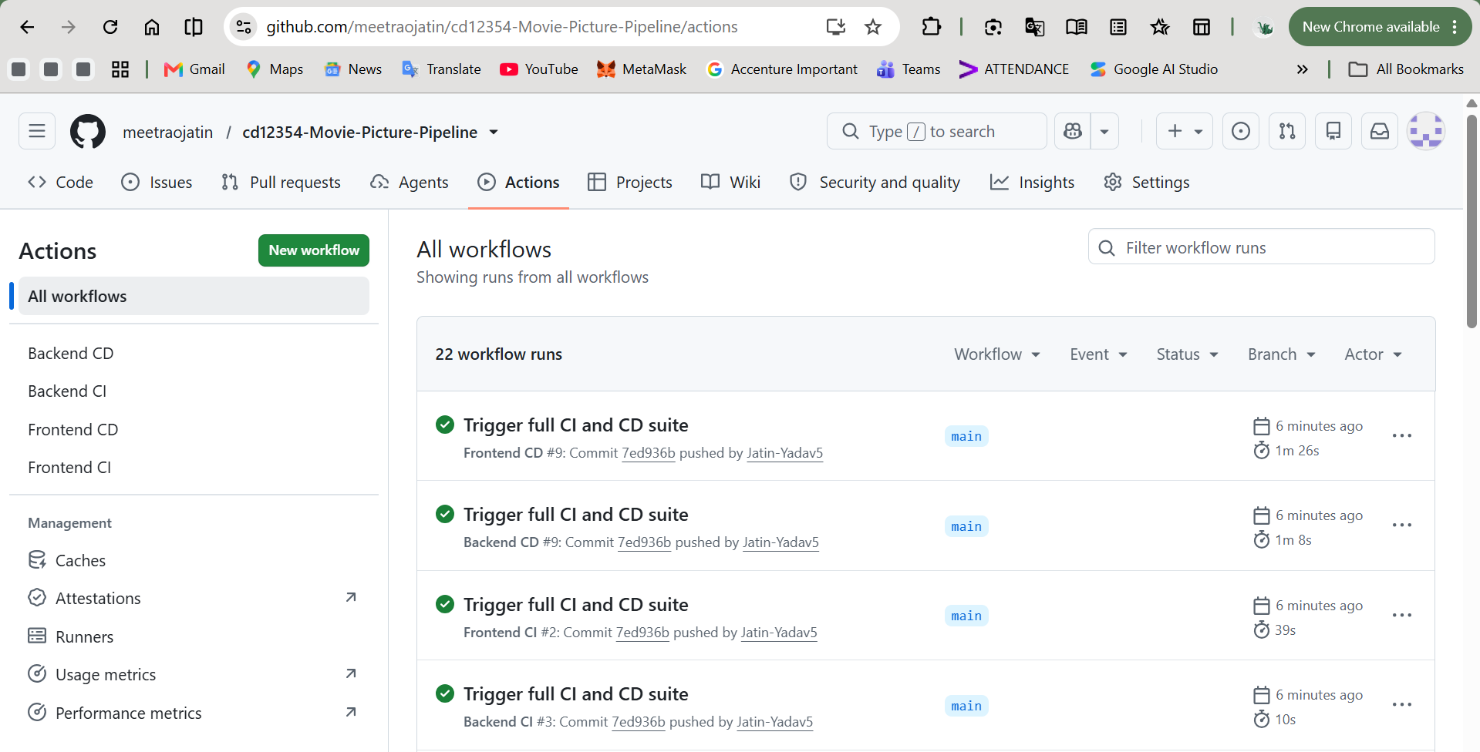

Get the Deployed External IPs
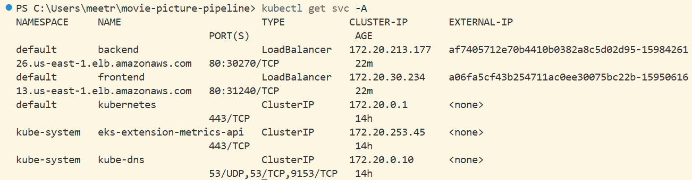

Terminal Pod Status:

Backend Endpoint:
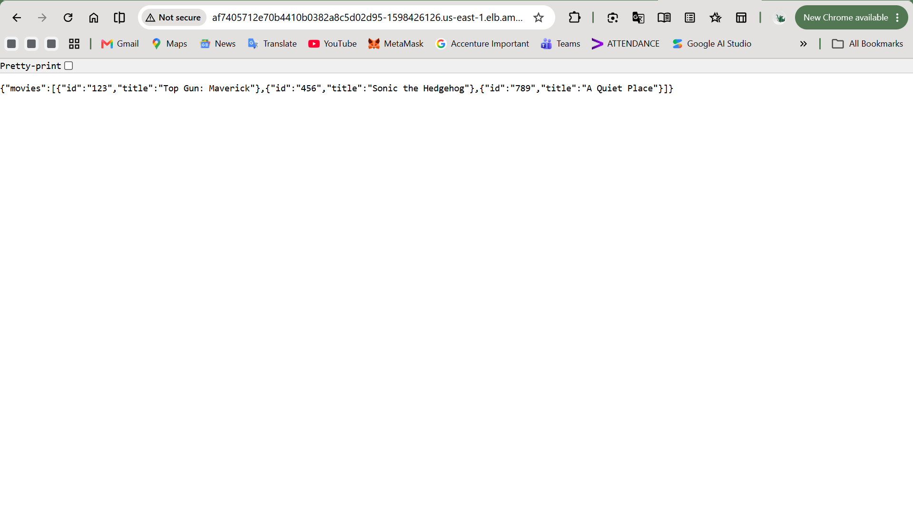

Frontend Web Application:
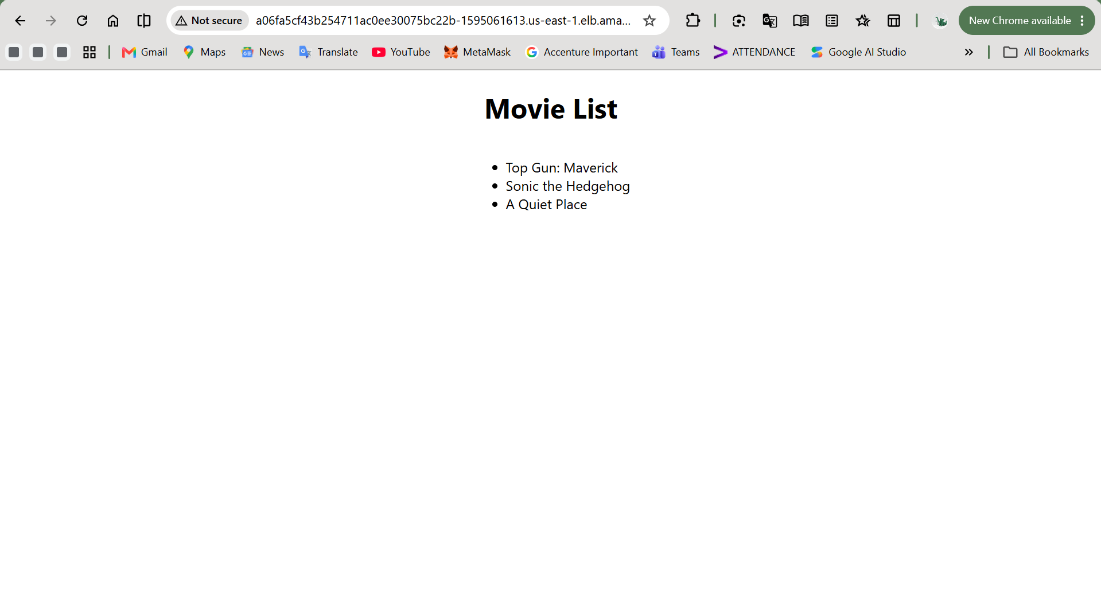

AWS Resource Cleanup / Billing Verification
